Agentic AI

TravelVerse is building an agentic AI system called TravelBot. It consists of a primary orchestrator agent and three sub-agents

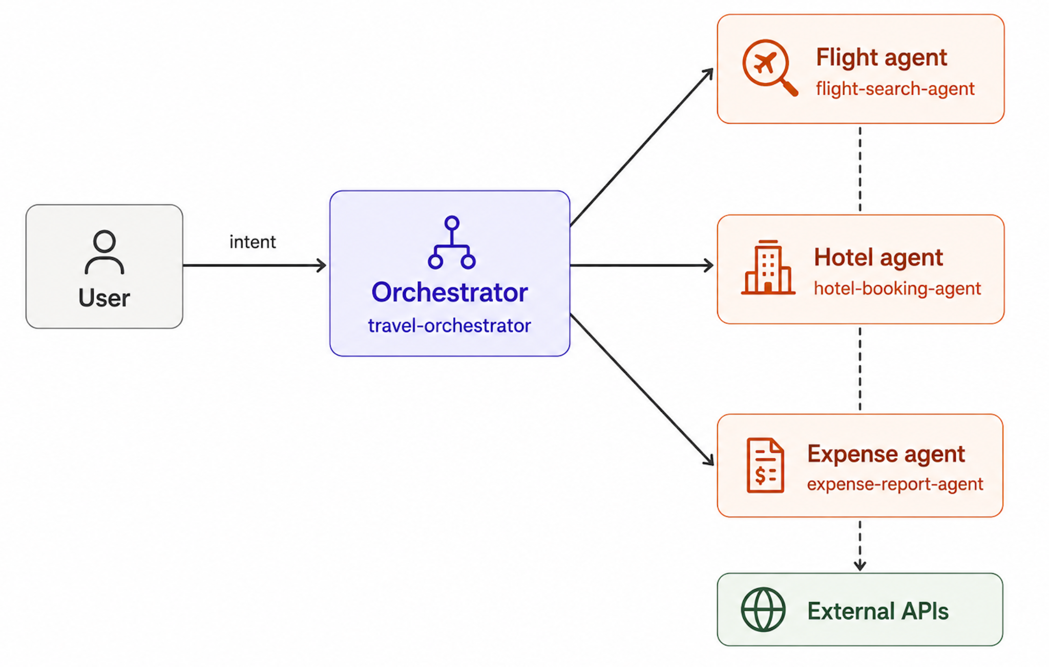

Agent | Role
Travel orchestrator | Receives user intent, plans, and delegates
Flight search agent | Queries flight APIs
Hotel booking agent | Books hotels on behalf of the user
Expense report agent | Generates and submits expense reports

Let’s use the use case in the diagram to demonstrate how we can register AI agents and manage them in WSO2 Identity Server. As you can see, admin is the super Administrator of TravelVerse.

Onboarding AI Agents
As of now user admin has Administrative privileges in Travelverse. Therefore admin will be creating agents in the Travelverse organization.

Lab 01. Register and Manage Agents

1. Create Agents
To learn how admin can register an AI Agent, follow these steps:

- In the WSO2 Identity Server Console, from the menu click Agents.
- Click + New Agent.
- In the opened up wizard,
  - Add the Agent Name, and Description to the respective fields.
    - Agent Name: Travel orchestrator
    - Description: Receives user intent, plans, and delegates
  - Tick Allow users to log in to this agent. The orchestrator talks to users and acts on their behalf, so it needs this. It creates an OAuth2/OIDC application for the agent and shows two more fields:
    - AI Agent Type: select Interactive Agent, because users work with the orchestrator in real time. (Background Agent is for an agent that works on its own and only contacts the user when needed.)
    - Callback URL (required for an interactive agent): the URL of the agent's application that receives the authorization code after the user logs in. For this lab, enter http://localhost:3000/callback.
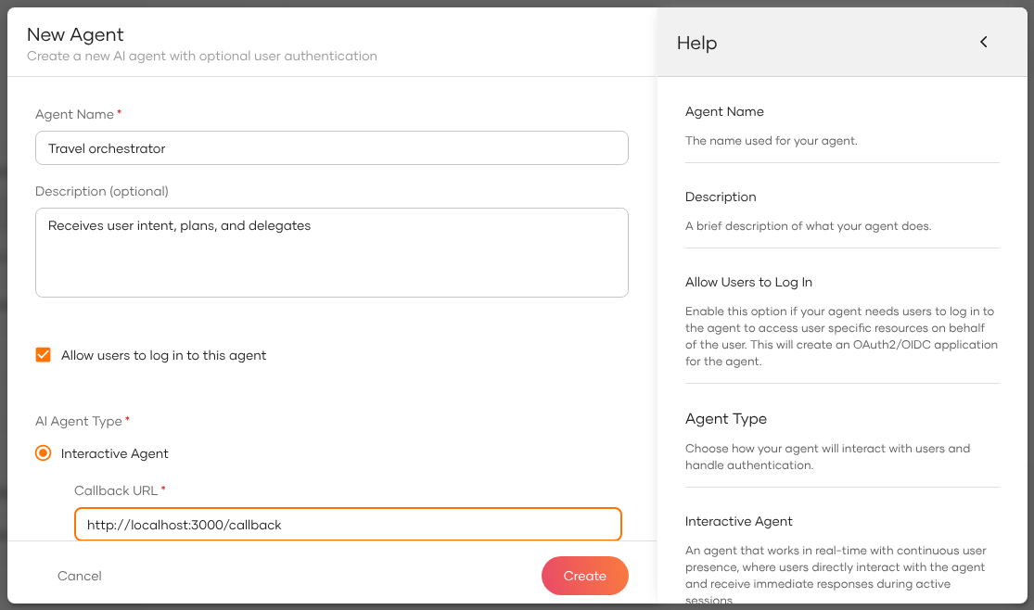
- Click Create.
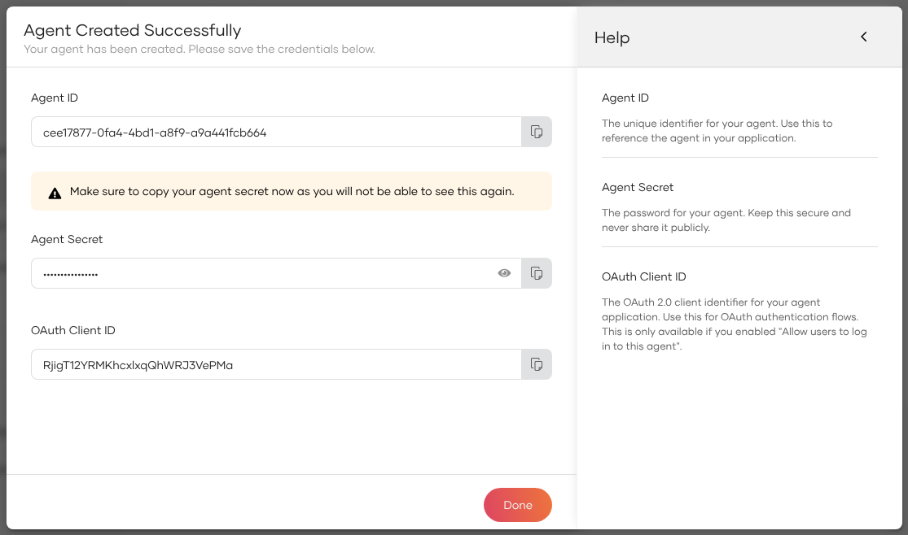
- Copy the Agent ID, Agent Secret and OAuth Client ID now. The secret is shown only once.
- Click Done.
- Create the other three agents (Flight search agent, Hotel booking agent and Expense report agent) the same way, but leave Allow users to log in to this agent unticked: users don't log in to them, the orchestrator calls them. All four agents are then listed on the Agents page.
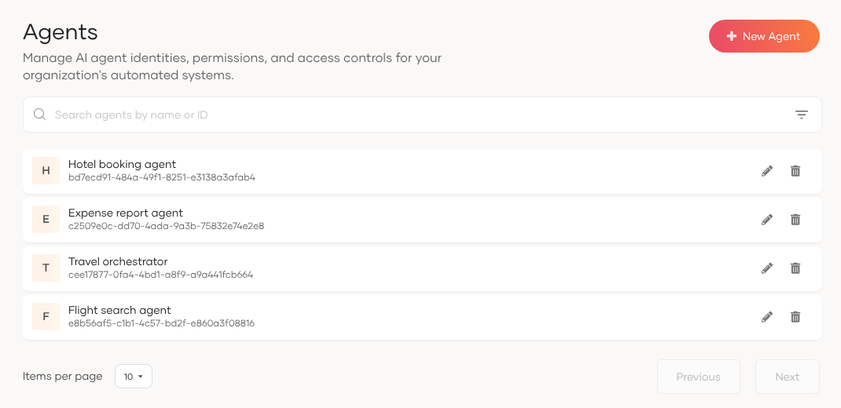

2. Regenerate Agent Secret
To regenerate the Agent Secret of the agent that you previously added, follow these steps:
- In the menu click Agents, then click the Travel orchestrator agent.
- Open the Credentials tab. It shows the Agent ID; the secret is not shown again.
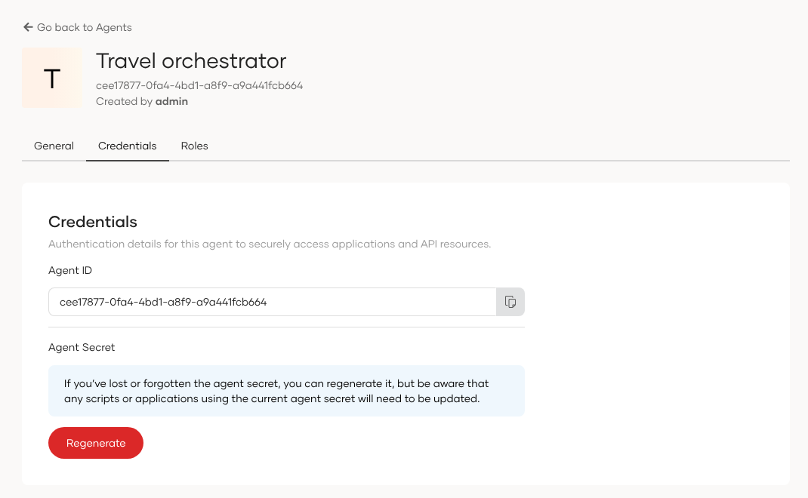
- Click Regenerate, then Proceed. Copy the new Agent Secret from the dialog and click Done. The old secret stops working.

Try It
To verify whether the agents you defined are correctly updated, follow these steps:
- Expand Agents menu Item and view the agents.
- You should see Travel orchestrator listed as an agent
- Select the Travel orchestrator agent, and click the Credentials tab.
- You should see Agent ID only.

